Comparable Entity Mining from Comparative Questions

A project presented to the
Department of Computer Science
University of Nebraska at Omaha

In Partial Fulfilment of the Requirements for the Degree

Dec 18th, 2016

SUPERVISORY COMMITTEE
Dr. Zhengxin Chen (Chair)
Dr. Sanjuktha Bhowmick
Dr. Abhishek Parakh

PREPARED BY
Jalan Macherla

Abstract

Comparing a thing with another is the usual tendency of human beings in the decision making process, but it is difficult to know the alternatives because of the limited knowledge. This way of comparing things is very common in our daily life. That being said, we provide a novel strategy to automatically mine comparable entities from the comparative questions which user present online. We present a weakly developed boot strapping algorithm by overcoming the existing system deficiencies. The proposed system improves the efficiency of mining comparators. The bootstrapping algorithm we use helps us in achieving high precision and recall. Our primary intention is to mine comparative entities from the comparative questions, and before that identify the questions provided is a comparative question or not. The proposed system extracts the entities from the comparative questions once our algorithm identifies the question as the comparative question and presents the user with possible alternative options. The trial and error final results present of our approach achieve F1-measure associated with 82.5 percent in comparison question identification in addition to 83. 3 percent in comparable entity extraction. These high scores way surpass the scores of the existing system.

Contents
Abstract 2
1. introduction: 4
1.1 Objective 5
1.2 Deliverable 5
1.3 Research Question(S) 5
1.4 Challenges Faced 6
1.5 Main Reference / Contribution 6
2. LITERATURE REVIEW 8
2.1 Identifying Comparative Sentences in Text Documents 8
2.2 Mining Comparative Sentences and Relations 9
2.3 Mining Knowledge from Text using Information Extraction 9
2.4 Learning Surface Text Patterns for a Question Answering System 10
2.5 Relational Learning of Pattern-Match Rules for Information Extraction 11
2.6 Comparable Entity Mining from Comparative Questions 11
3. academic value 13
3.1 Information Storage & Retrieval 13
3.2 Database Management System 13
3.3 Software Specification & Design 14
4. High level details 14
4.1 Block Diagram of the Project 14
4.2 Program Flow 16
4.3 Requirements 17
4.3.1 Hardware Requirements 17
4.3.2 Software Requirements 18
5. IMPLEMENATATION 18
5.1 Design Artifacts 21
6. EXPERIMENTS COnDUCTED & ANALYSIS 26
6.1 Crawling Effectiveness Comparison 26
6.2 Crawling Coverage Comparison 26
6.3 Large Scale Online Crawling 27
6.4 Source Page/Navigational path evaluation 27
7. CONCLUSION 29
REFRENCES 30
APPENDICES: 30

introduction:

Selection of a thing among several available options is decisive in nature, but to have options prior to selection is of interest. Sometimes we have many options, sometimes we have none, and sometimes it is limited to a few. Users usually compare entities for selection. Comparing entities having a common utility but with distinguished features is decision making. When we search for a thing in a search engine, we get the results which are related to the search query, we find links to the website where our query term is used, and we find images and so on. But, it’s hard to find what would be alternatives to your search query. For example, if you search for an iPhone, you get all the results that are related to iPhone, but nowhere you find that a blackberry or a Nokia displayed in the search results, this is because the query term is not related to them. What if you want to find an alternative to iPhone? Yeah, you can answer this, as almost everyone knowns an iPhone. What if I ask you, what are alternatives to Statin?
So our architecture attains the objective of extracting many relevant things from the users who post questions online. The main components of decision making process are the comparative questions and the comparators in that question.
Comparative questions: A question intended to compare entities of similar types.
Comparators: Entities in the comparative questions which are to be compared.

It is difficult to decide whether two entities can be compared or not. A question posted necessarily need not be a comparative question. For example, which city is good, this is not a comparative question, is Omaha best city? Even this is not a comparative question. Which city is better Omaha or Lincoln, this is a comparative question as we are trying to compare two cities in the above example. Here Omaha and Lincoln act as comparators.

Our primary intention is to mine the comparators from the comparative questions and suggest alternatives from the previous online user’s request. Knowing popularity of comparators among the users will be very helpful to companies to know their competitor.

Objective

The objective of this research is to present a novel way to mine comparative entities from comparative questions that users posted online to address this issue. We develop a weakly supervised bootstrap algorithm to ensure we have high precision and recall, through a large collection of online archives. The results obtained show very high F1 measure and our ranking results show the relevance to the user’s entity.

1.2 Deliverable

The application which would be developed would help users in finding alternatives to their entity. The users can post a question online and find the answer to it from the questions we already have in the database and build a comparator sets based on it. The alternatives provided by the application would be ranking based, highest being displayed at the top.

1.3 Research Question(S)
- Know the existing approach and the previous approaches and knowing their drawbacks and researching on those drawbacks.
- Knowing the concepts of association rules and how they can be wisely used in the project to help in decreasing the ambiguity.
- How to store the raw data and how to make useful information from that raw data.
- Investigate in pattern evaluation and pattern generation for identifying the comparative question.

1.4 Challenges Faced
- The most important challenge faced by me is to understand the existing algorithm and enhance it, so that I have more efficiency.
- Finding online questions and manually answering them, so that it is saved in the database.
- Implementation of the bootstrap algorithm.
- How to resolve the ambiguity during answering the comparative questions.

1.5 Main Reference / Contribution

Comparable Entity Mining from Comparative Questions by Shasha Li, Chin-Yew Lin,
Young-In Song, Zhoujun Li is the main paper which I have referred in coming up with my project. I have used the existing procedure used in the main paper, and enhanced it. I have altered the bootstrapping algorithm in order to attain high precision and recall and overcome the drawbacks of the main paper.
The following is the detailed major differences and enhancements compared to the main reference paper and my research.

The existing system proposed by Jindal and Liu was taken to great heights by the main reference paper by achieving good precision and recall percentage.

Suggesting the user alternatives of a word / entity. User when enters an entity to which he needs to find the alternatives, he has to simply enter that keyword, and the system takes care of the rest. The proposed algorithm traverses the databases and through the questions and finds the frequent alternatives, the most frequent being displayed at the top.

Change the boot strap algorithm, minimizing the data selected initially with only selective comparative question which makes the proposed system more adaptive when a new comparative question is posted to the system.

The most important part of my contribution is using of the association rules. I have used the association rules making use of the support and confidence in making the output make more sense after the boot strap algorithm.

Graphical representation of the most keyed words from the user perspective. This helps the user in finding his nearest rivals as per the internet search to be precise our proposed system search.

LITERATURE REVIEW

The work on comparator mining is connected

Identifying Comparative Sentences in Text Documents

N. Jindal and B. Liu, “Identifying Comparative Sentences in Text Documents,” Proc. 29th Ann. Int’l ACM SIGIR Conf. Research and Development in Information Retrieval (SIGIR ’06), 2006, 244-251.
Comparisons can be subjective or objective. It’s more like comparing one object with another, for example, this city A is much better than city B. This paper studies how to identify comparative sentences. The paper clearly addresses the problem of identifying the comparative sentences. The approach first categorizes comparative sentences into different types and then presents integrated pattern discovery in identifying comparative sentences from text documents. The classification of sentences into comparative and non-comparative is the basic idea of the paper.
The approach takes into account of the Class sequential rules in building the learning model. The basic approach followed is the combination of the class sequential rules and machine learning. Use of machine learning methods to overcome the previous drawbacks is used in distinguishing comparative and non – comparatives. The paper has taken into account of the user preferences and implicit comparators also. The way of extracting comparative sentences from the text based is used in many applications. The main disadvantage is that it suffered from low recall though high precision was attained.

Mining Comparative Sentences and Relations

N. Jindal and B. Liu, “Mining Comparative Sentences and Relations,” Proc. 21st Nat’l Conf. Artificial Intelligence (AAAI ’06), 2006.
The basic idea of the paper is to have comparative relations from the already identified comparative questions. One way to evaluate an event is to compare with similar event. Class sequential rules and label sequential rules are used to accomplish the above task. From the input, they identify the comparative sentences and classify the identified comparative sentences into different classes. After that extract comparative relations which involve extraction of entities and their features that are being compared and comparative keyword. The main idea of the paper hovers around the basic agenda, the way of evaluation is to compare with similar entity. It suffered from low recall, though the precision is reasonably high.

Mining Knowledge from Text using Information Extraction

R.J. Mooney and R. Bunescu, “Mining Knowledge from Text Using Information Extraction,” ACM SIGKDD Exploration Newsletter, vol. 7, no. 1, 2005, 3-10
[13] M. E. Califf and R. J. Mooney. Bottom-up relational learning of pattern matching rules for information extraction. Journal of Machine Learning Research, 4:177– 210, 2003.
[28] C. D. Fellbaum. WordNet: An Electronic Lexical Database. MIT Press, Cambridge, MA, 1998.
[59] L. A. Ramshaw and M. P. Marcus. Text chunking using transformation-based learning. In Proceedings of the Third Workshop on Very Large Corpora, 1995.

Paper discusses about use of two approaches in natural language information extraction for text mining. The first is extraction of general knowledge directly form the text and the second one is to first extract the structured data from the unstructured data or the semi structured data by applying traditional knowledge discovery in database methods. Supervised machine learning methods were preferred than the manually developing patterns as the machine learning method is successful in developing robust information extraction systems. Many IE systems simply treat text as sequence of tokens however many others treat them other tools like POS, learned extraction rules [13], phrase chunkers to identify phrases to extract [59], others use lexical semantic databases, as WordNet [28].
The whole paper revolves around extraction of information which is structured in nature from unstructured data or semi structured data. The main disadvantage is that it cannot meet the demand of the ever increasing corpus.

Learning Surface Text Patterns for a Question Answering System

D. Ravichandran and E. Hovy, “Learning Surface Text Patterns for a Question Answering System,” Proc. 40th Ann. Meeting on Assoc. for Computational Linguistics (ACL ’02), pp. 41-47, 2002.
Open domain question and answering systems use external knowledge and tools for answering. A fairly list of surface patterns was a way to evaluate them. Certain type of answers are expressed using characteristic phrases, authors try to automatically acquire patterns and try to measure the accuracy of the patterns. Pattern learning algorithm is described by constructing a pattern for each individual question type.
The algorithm is to select an initial example and search for it in a search engine and select the top thousand results and apply a sentence breaker to the selected documents. In the selected documents retain only those sentences that contain both the question and answer term, then remove the tags, tokenize the input and pass the retained sentence through suffix tree constructor. Lastly pass each phrase through filter and retain only those phrases / sentences which contain both question and answer. The proposed system assumes that each sentence is a simple sequence of words. The disadvantage of the system is it doesn’t make a clear distinction between lower and upper case.

Relational Learning of Pattern-Match Rules for Information Extraction

M.E. Califf and R.J. Mooney, “Relational Learning of Pattern- Match Rules for Information Extraction,” Proc. 16th Nat’l Conf. Artificial Intelligence and the 11th Innovative Applications of Artificial Intelligence (AAAI ’99/IAAI ’99), 1999
Information extraction systems are difficult and time consuming to build and they are domain specific and its complex to port to new domains. Robust Automate Production of Information Extraction system proposed learns rules for the complete information extraction. The resulting rules extract the desired items directly form the text without parsing or processing. The learning algorithm primarily consists of specific to general search of patterns. First most specific patterns are created for each example. Pre filler contains item for each word from the beginning of the document to the word immediately preceding the filler. Now RAPIER attempts to compress the specific rules and try to generalize them, initially it take two rules and tries to create a general one. RAPIER system uses relational learning to construct unbounded pattern match rules for information extraction.

Comparable Entity Mining from Comparative Questions

[1] Nitin Jindal and Bing Liu. 2006a. Identifying comparative sentences in text documents. In Proceedings of SIGIR ’06, pages 244–251.
In the World Wide Web era comparison involves search of the term in the web, scan through the pages, find reviews and so on. The paper focuses on finding the alternatives to a word. The comparators are mined from the comparative questions. If some user is posting a question which has tries to find the relation between two words, then that means that the user is trying to find the relation between those two entities. We simply rely on this search from the user in finding comparative entities.
What can be compared and what cannot be compared, how to identify whether the question supplies is comparative question and how to retrieve the comparators without comprising on precision and recall is the main idea of the paper.

The authors use the boot strapping algorithm to overcome the drawback of the previous approach proposed by Jindal and Liu [1] which lags in low precision and recall in entity mining. Their approach is using Class sequential rules and Label sequential rules. The proposed system makes three kinds of patterns in evaluating whether a given user question are comparable or not. It uses Lexical patterns, Generalized patterns and Specialized patterns. The boot strapping algorithm process starts with a single IEP (indicative extraction pattern), from it set of initial seeds of comparator pairs are extracted. All the questions which contain these comparator pairs are considered as comparator questions. All the reliable ones are added to IEP repository. In the paper they have presented a weakly supervised method to identify comparative questions and extract comparators

academic value

My course work at College of Information Science and Technology at University of Nebraska, Omaha, and internship at Election System and Software, and last at present work CSG International helped me gain sufficient knowledge. I have learnt a lot during the school, my concentration was databases, and the following courses helped me successfully implementing my project Comparable Entity Mining from Comparative Questions [1]

3.1 Information Storage & Retrieval

How to store the information and effectively retrieve the stored information, how to use the association rules which is a major enhancement to the project by aptly making use of support and confidence in retrieving the desired results, this course has helped me in achieving these. These concepts learnt in the course laid a strong foundation for proposed project. The main important part the course which has helped me in the project is the information extraction.

3.2 Database Management System

Efficient storing of the data and retrieval is important to any project. My concentration is databases and I have taken three courses in this concentration and all of them equally helped me. My project always deals with the data and its storing, as the storage keeps on increasing data model should be built to handle such increasing load. This course has taught me all the basic database requirements I should keep in mind before designing. This course has helped me to understand concepts like relational models, data modelling, SQL, database administration and security, database design, normalization and so on.

3.3 Software Specification & Design

This course has helped me to understand the early phases of software development, particularly requirements gathering. I also understood the different phases of Software Development Life Cycle. This course also helped me in read and write formal specifications of any existing software’s used during the project. The success of any software project depends on efficient planning, creating, testing, and deploying. The Software Requirements Specification document that I created for a project that I did in this course helped me to describe the software system being developed, to list the functional and nonfunctional requirements. It helped me to visualize what the system is supposed to do and not to do. It also helped me to plan, identify risks and estimate costs. Apart from the understanding the various requirements during the development cycle this course helped in creating documentation for an application or a project.

High level details

4.1 Block Diagram of the Project

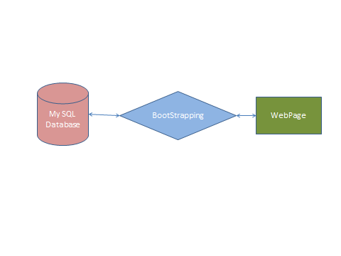
Fig 1.Block diagram of the project

The above block diagram represents overview of the proposed project. The users access the webpage, users can search for comparators or comparator questions. Webpage through the server reaches the database. The bootstrap algorithm does the necessary processing and stored the data in the data base based on the user input / query. The database stores all the information regarding the users, admins, and their querying. Though both the user and administrator can answer the questions, it is only the administrator who can authorize the database directly and manage, maintain it.

Program Flow

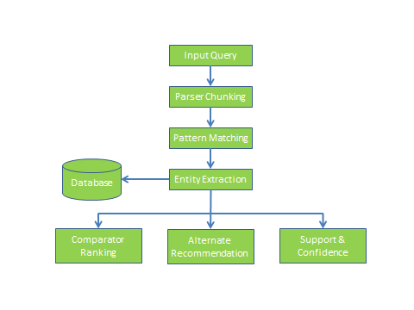
- Take input from user.
- Check whether the input question is a valid question or not.
- If it’s a valid question, then the regular process should follow.
- Match the input with the existing and extract comparators from them.
- Extract comparators from the comparative questions.
- Suggest user with alternatives for a give input.

4.3 Requirements

4.3.1 Hardware Requirements

- System : Pentium IV 2.4 GHz.
- Hard Disk : 40 GB.
- Floppy Drive : 1.44 Mb.
- Monitor : 15 VGA Colour.
- Mouse : Logitech.
- Ram : 512 Mb.

4.3.2 Software Requirements

- Operating system : Windows XP/7.
- Coding Language : JAVA/J2EE
- IDE : Eclipse
- Database : MYSQL

IMPLEMENATATION

The application is designed using web technologies (html, css and JavaScript) for user interface and input validation. Java technologies are used (servlets, jsp and jdbc) for dynamic application logic processing.
There are two users in the application
1) Administrator
2) Users.
Application allow administrator to login and load dataset once after loading dataset application apply comparative question identification technique called IEP to find out comparative questions from loaded dataset. Admin can add new questions manually and can give answers to those questions and the same can be done by users also. Manually added question and their answers will be saved in mysql database.

Dataset Information
The dataset used for the application is downloaded from yahoo answers site called ‘Yahoo Research Alliance Webscope program’. This dataset contains nearly 6000 questions and answers we will take only comparative questions from 6000 questions by applying IEP technique.

Program Details
Load.java: This program is invoked to read the path of uploaded dataset. User will first choose dataset directory and upon clicking on a button user interface will call Load program to read the path of selected dataset.
ReadQuestions.java: This program will be invoked by Load program to read questions from loaded dataset. This program read all questions from dataset and stored in java JVM memory for further processing.
PosTagger.java: This program read all questions from JVM memory store by ReadQuestions program. After reading each question this program will apply following technique to determine given question is comparative or not. [citation]
Lexical patterns: These patterns indicate sequential patterns consisting of only words and symbols ($C, #start, and #end).
Example: Which is better, Omaha or Lincoln?

Generalized patterns: A lexical pattern is too specific for matching. Lexical patterns are generalized by replacing one or more words with their POS tags.
Example: Which city is better, Omaha or Lincoln?

Specialized patterns: Pattern specialization by adding POS tags to all comparator slots.
For example, from the lexical pattern “<$C or $C>” and the question “Omaha or Lincoln?”, “<$C=NN or $C=NN?>” will be produced as a specialized pattern.
Example: Omaha or Lincoln?

TagWord.java: Using this program we are assigning Part of Speech tag to each word available in a question.

Phrase Chunker: Generate sequence for the comparative question. If the IEP is a pattern without generalization, we just need to tokenize the questions and the sequence is the list of resulted tokens. Otherwise, phrase chunking is necessary. The sequence is a list of resulted chunks. Take the question “Which is better phone iphone or nokia n95 ?” for example. If we apply the pattern “Which is better $C or $C?” to the question, we generate a sequence “which|is|better|phone|iphone|or|nokia|n95|?” If we apply pattern “Which is better NN $C or $C?” to the Question, a sequence “Which/WP | is/VBS| better/ JJR|phone/NN|iphone/NP|or/CC|nokia n95/NP|? /?”. Check whether sequence of the question matches the given pattern. If IEP is a specialized pattern, the POS tag sequence of extracted comparators should follow the constraints specified by the pattern.

Rules for Phrase Chunker

/*
* Heuristic rules
* NP* -> NP
* NN* -> NN
* NN + NNS -> NNS
* NP + NPS -> NPS
* More + ADJ -> JJR
* Most + ADJ -> JJS
* ...
*/
Search.java: This program read input from user and checks weather given input is comparative or not by applying above technique and if question comparative then application suggest all related answers for given comparative questions and all answers previous user search for same or other comparative questions

Modules Description

5.1 Design Artifacts

Use case Diagram
Use case diagram for Admin:
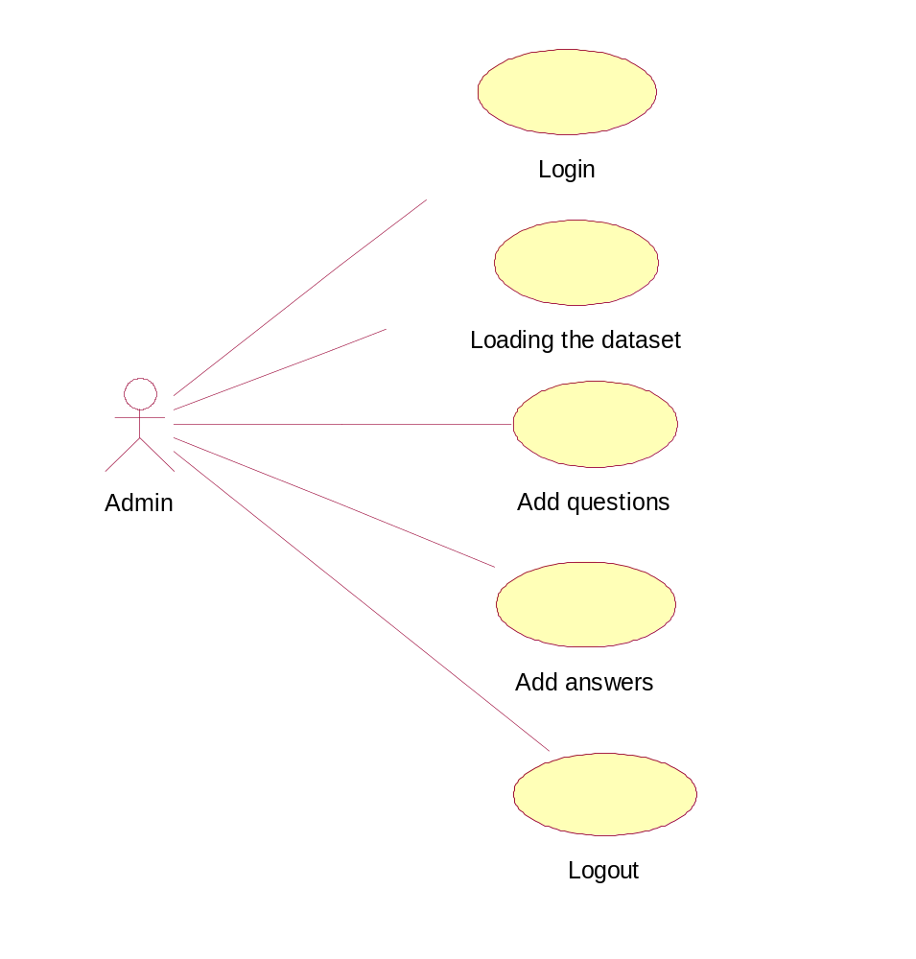

Use case diagram for user:
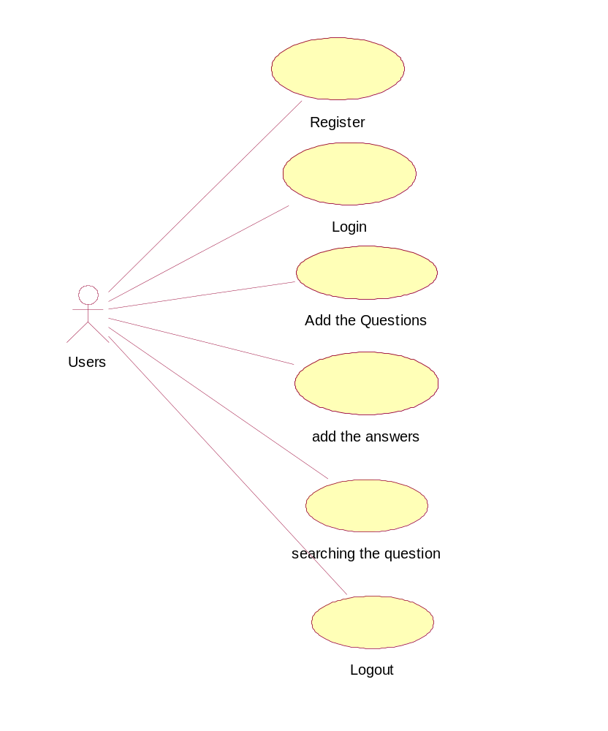

Class diagram:
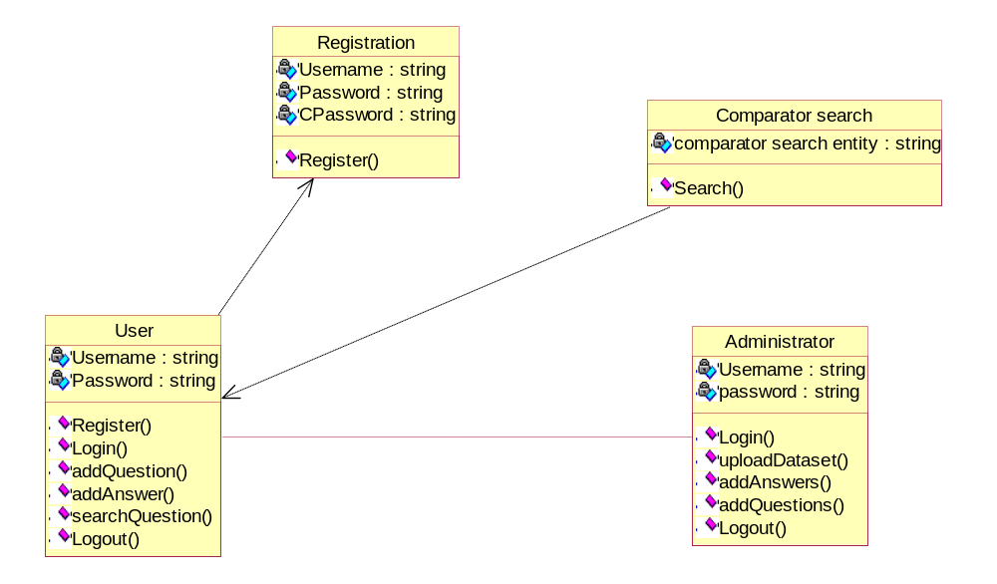

Sequence diagram:
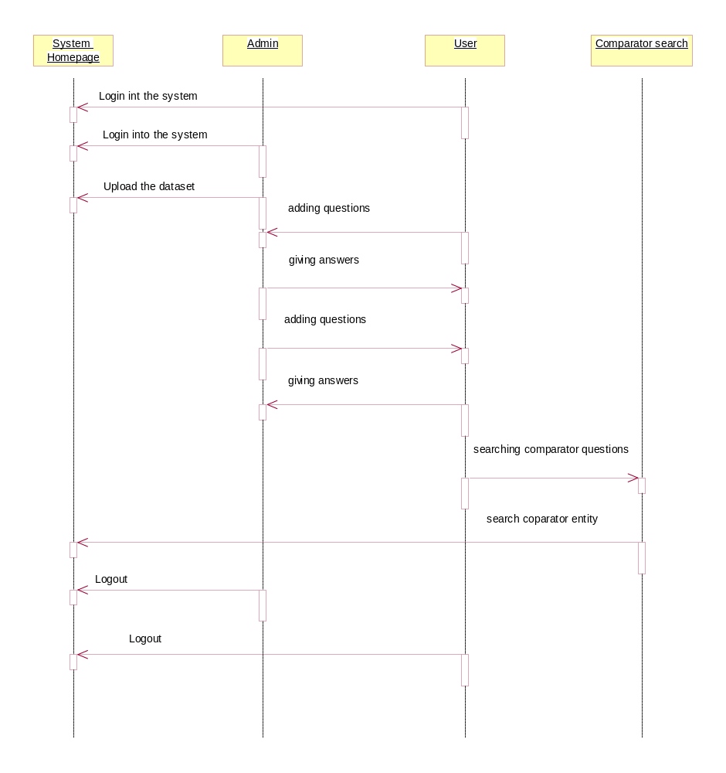

EXPERIMENTS COnDUCTED & ANALYSIS

6.1 Crawling Effectiveness Comparison

6.2 Crawling Coverage Comparison
I used the Coverage measure and applied them on the forums above to evaluate this section and compared the results with that of FoCUS. Coverage measure is explained as below
Coverage measures the percentage of crawled thread pages of a forum crawled to all retrievable thread pages of the forum

Columns are explained below,
Forum: Entry URL of a Forum that passed as input to the crawler
#Threads: Number of Thread pages identified by this crawler implementation
#Total Threads: Total number of approximate thread pages information from the site(http://www.thebiggestboards.com/), where it has each and every internet forum information like number of member enrolled, number of topics discussed, number of posts, etc.

Analysis:
Even the numbers for each forum in the table above looks higher compared to FoCUS, this has performed on par with FoCUS with 99% of coverage on threads in a forum. The numbers are higher for each forum is just because of increase in threads from the point when FoCUS has conducted experiment to today

6.3 Large Scale Online Crawling
The web forum crawler implemented has apart from the above forums this has automated to test around 40 other forums of different sizes to measure the overall effectiveness and coverage amoung large quantity of forums.
The average effectiveness amoung all the 48 forums tested stands at 92% compared to 98% of FoCUS. The number looks relatively low compared to FoCUS even though the threads coverage of this forum is almost equal to the FoCUS. After careful analysis it is observer that this crawler has considered many URL links which has both the multimedia and plain text has anchor and are not part of any thread. This is considered to mainly increase the coverage of the crawler to more threads. On the other side the coverage metrics seems to on par with FoCUS with 99% which is equal to the coverage of FoCUS.
The largest forum (http://forums.gentoo.org/) crawled by this crawler has as many as 767,898 pages with 720,458 whereas the lowest forum (http://www.coinforum.com/) crawled by this has as low as 22,100 pages with 20,129 thread pages.

6.4 Source Page/Navigational path evaluation

Analysis:
The crawler has decent results at 92% correctness in evaluation of navigation of a page. As I explained before the result percentage may or may not go for large forums if we take more number of random pages. The total count of a URL of a selected page on forum cannot be verified practically as we need to manually parse the forum site to find each of the URL. It is mainly used for statistical purpose in web application rather than as information for indexer in

CONCLUSION
Implemented the bootstrap method. System identifies the comparative questions posted by the users. The system first identifies whether it’s comparable or not in the first place. The alternatives are suggested to the users who search for a particular word for which one is not aware of the alternatives. Hybrid approach is implemented by taking into account both the boot strap algorithm and the association rules. This helped in achieving high recall and the high precision. Support and Confidence are nowadays popular indicators. These techniques may be used by the competitors to know their nearest competitor in the market.

Future work

I would work on Ambiguity entity conflict. There are some situations where the results would result which are not of user’s intention. Some words may fall into different datasets and knowing to which dataset that particular word fits into is important in order to retrieve the correct results from the database. Since the dataset used is very small in nature, performance is good as of now. Consideration of time taken to retrieve the relevant information is very important if the data dealt with is very huge. Finally how to effectively use the logic for acronyms to fit into datasets (like ‘CSG’, ‘AAPL’).

REFRENCES

APPENDICES:
Application Screenshots:
Index page
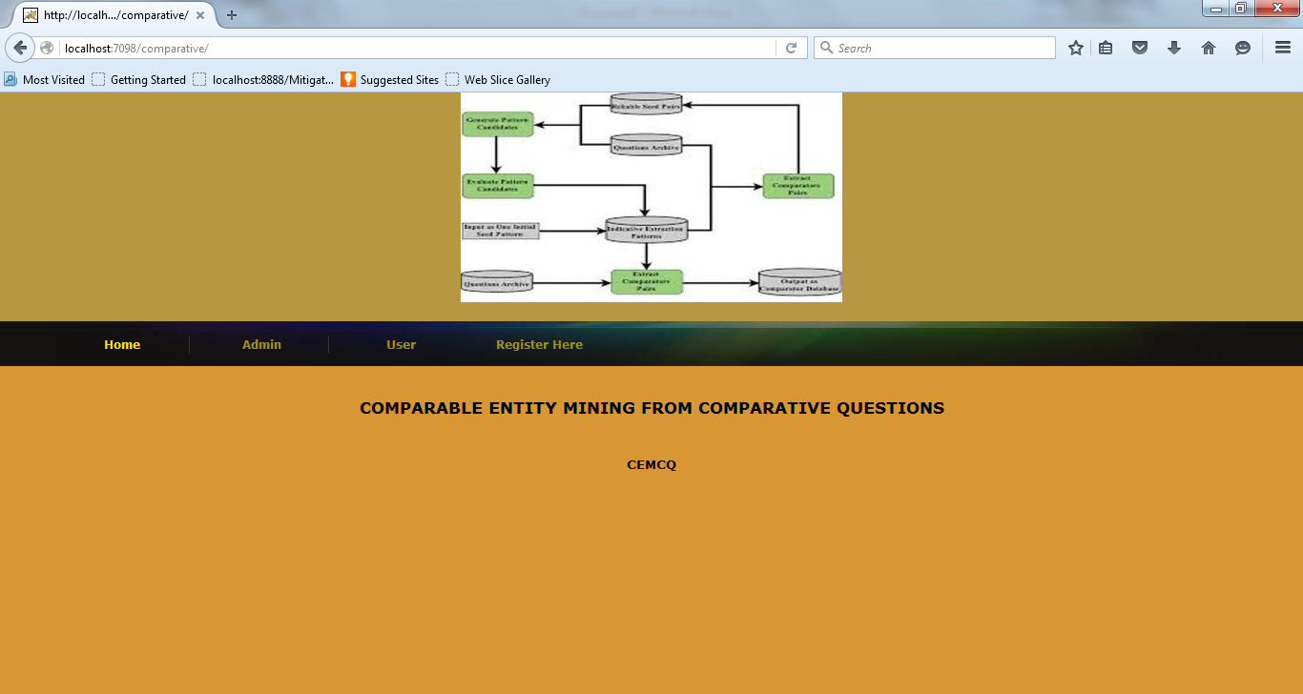

Admin Login Page

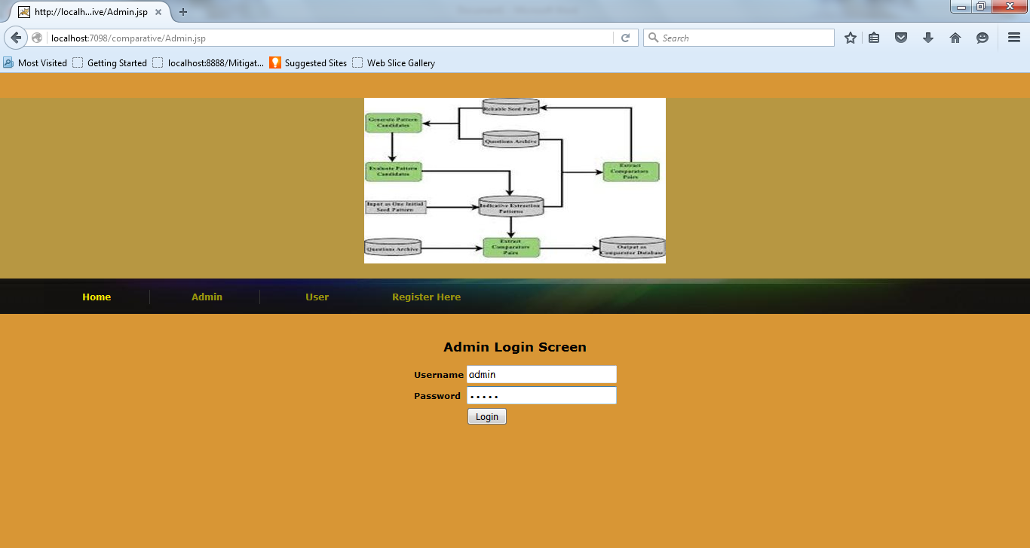

Admin Screen

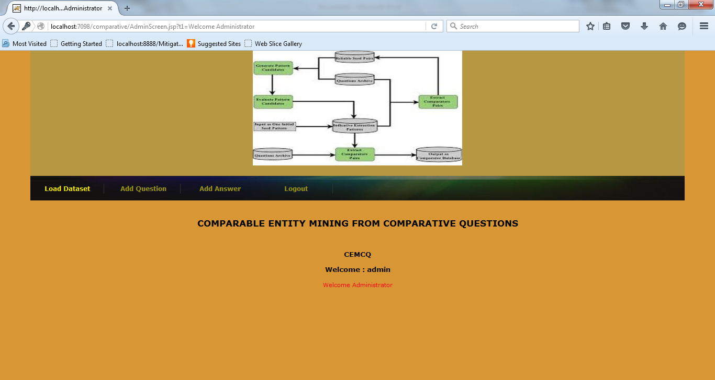

Admin to add question

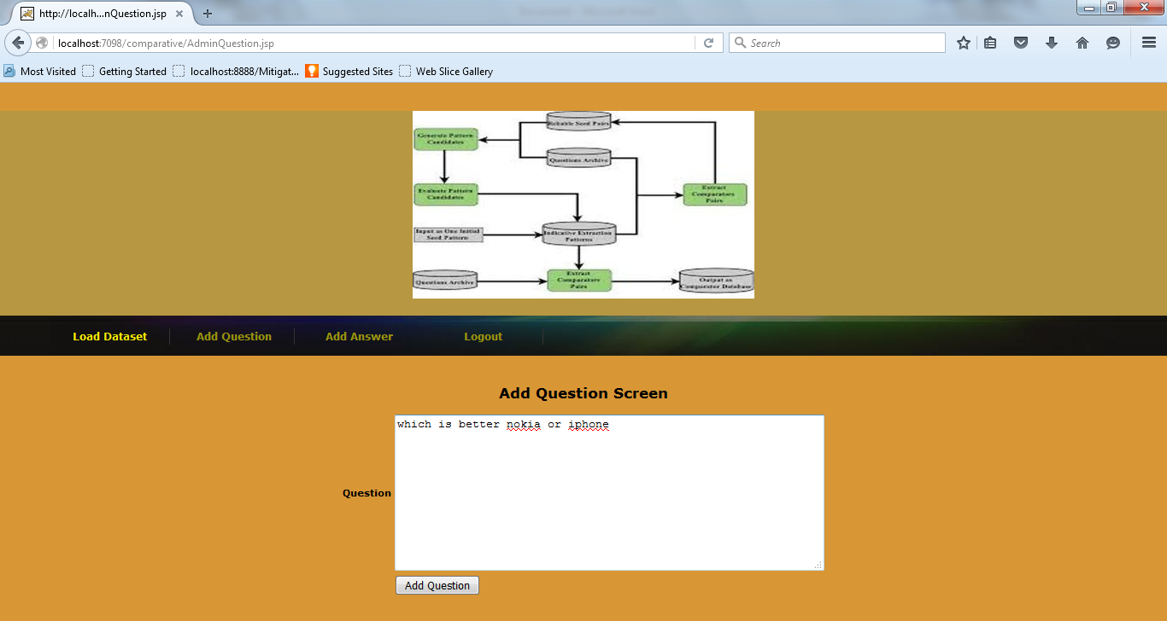

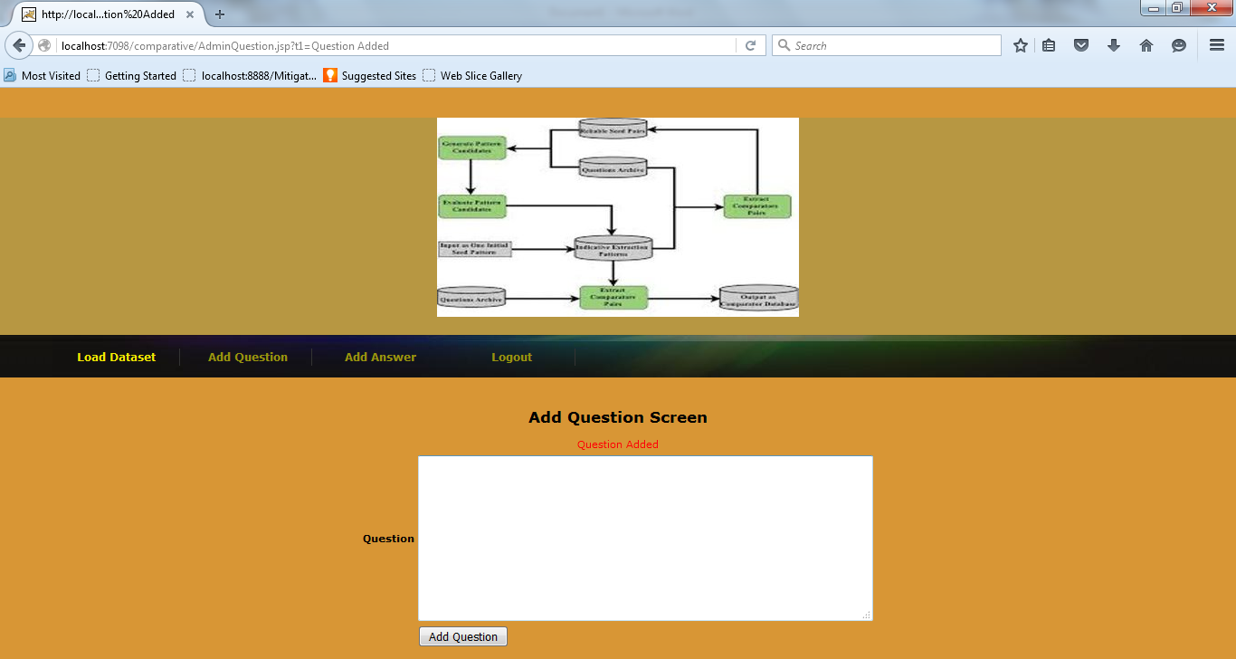

Admin to give answers

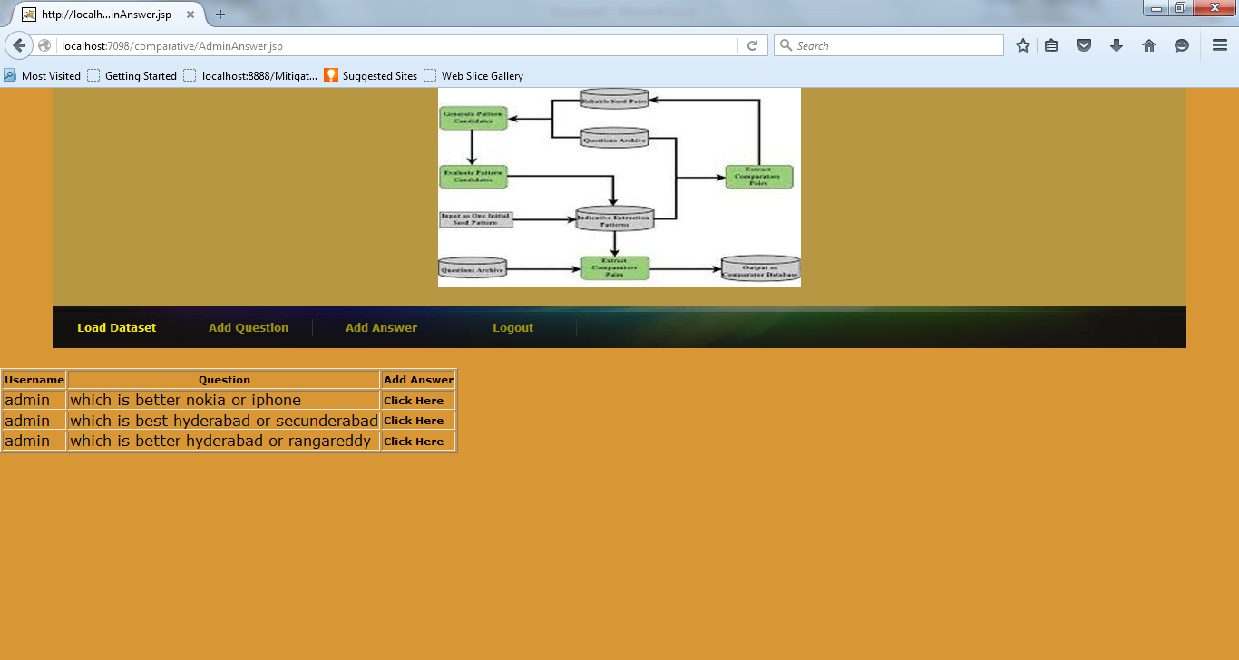

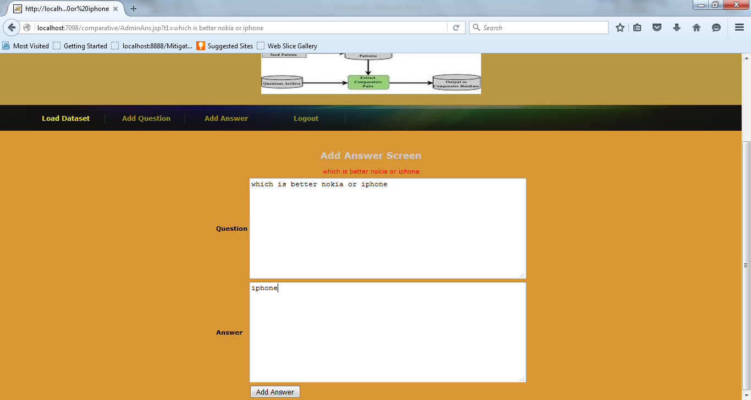

After giving answer

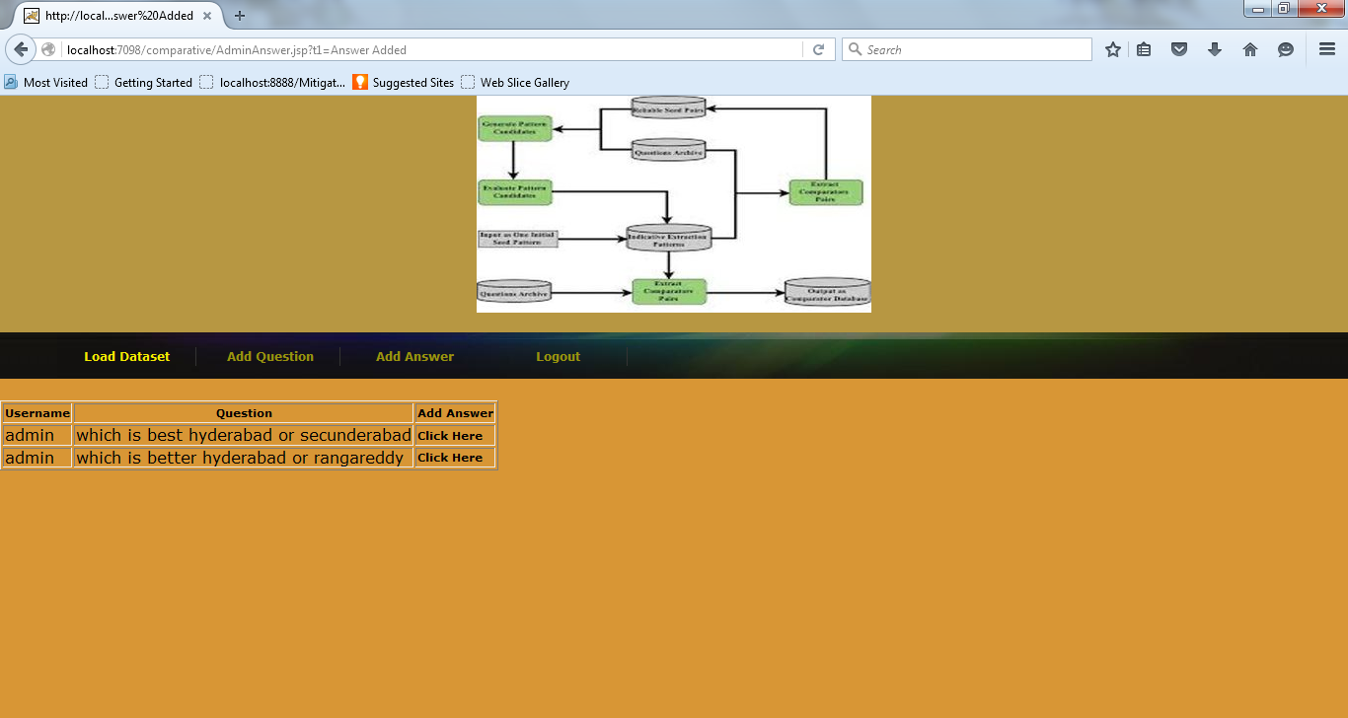

Admin to load dataset and build comparative question and answers collections

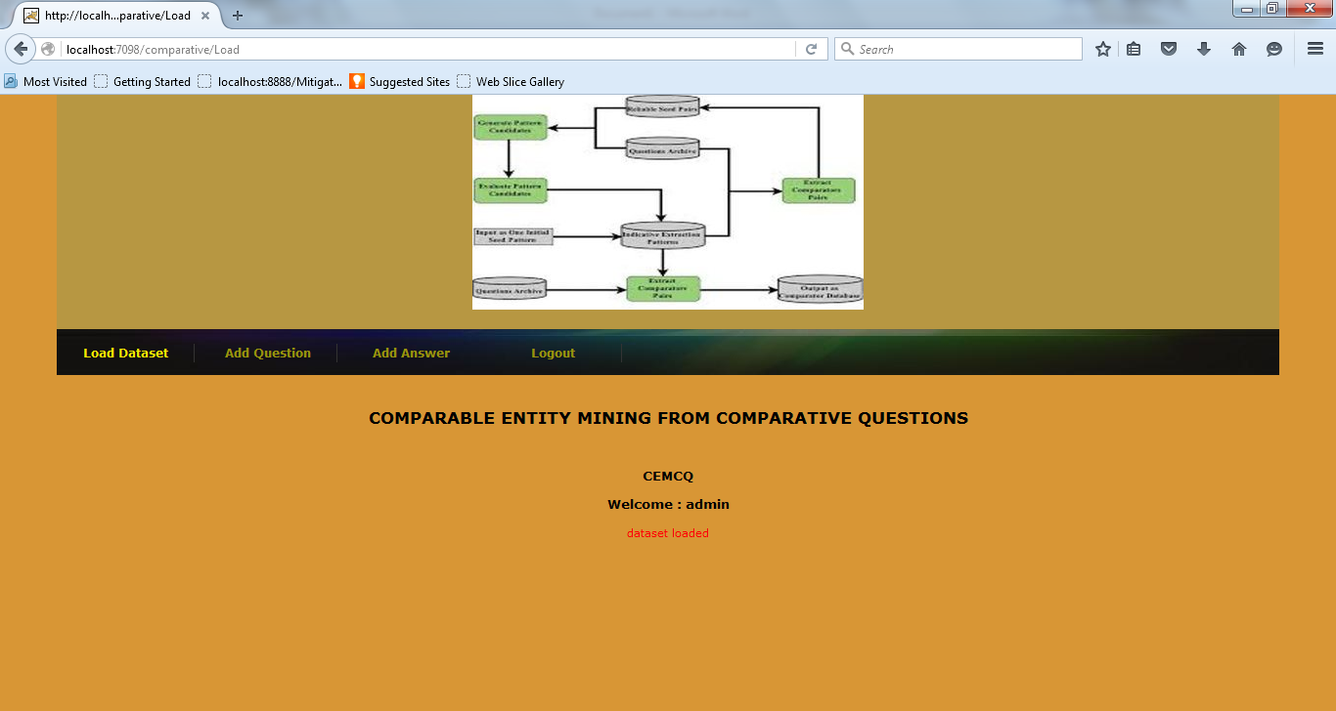
User registration screen

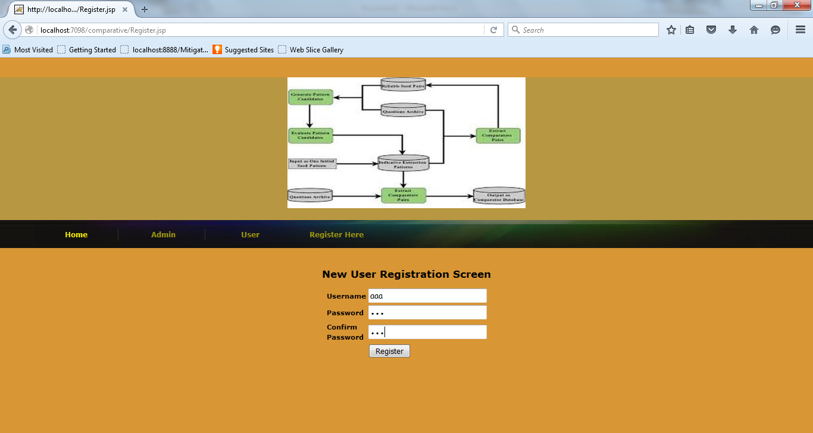

User login
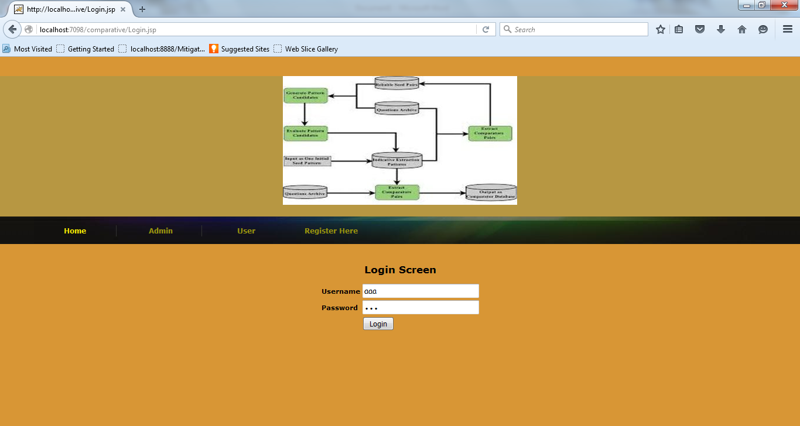
User screen

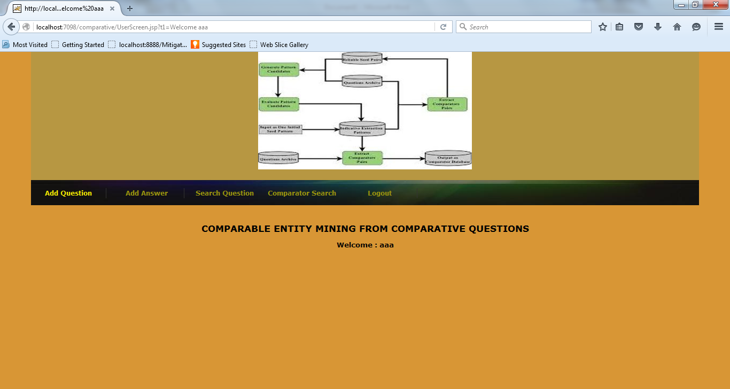

User to add question

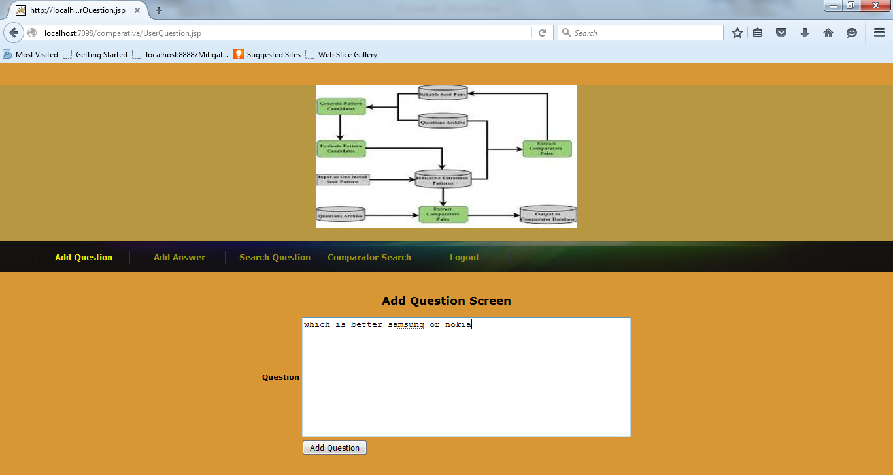

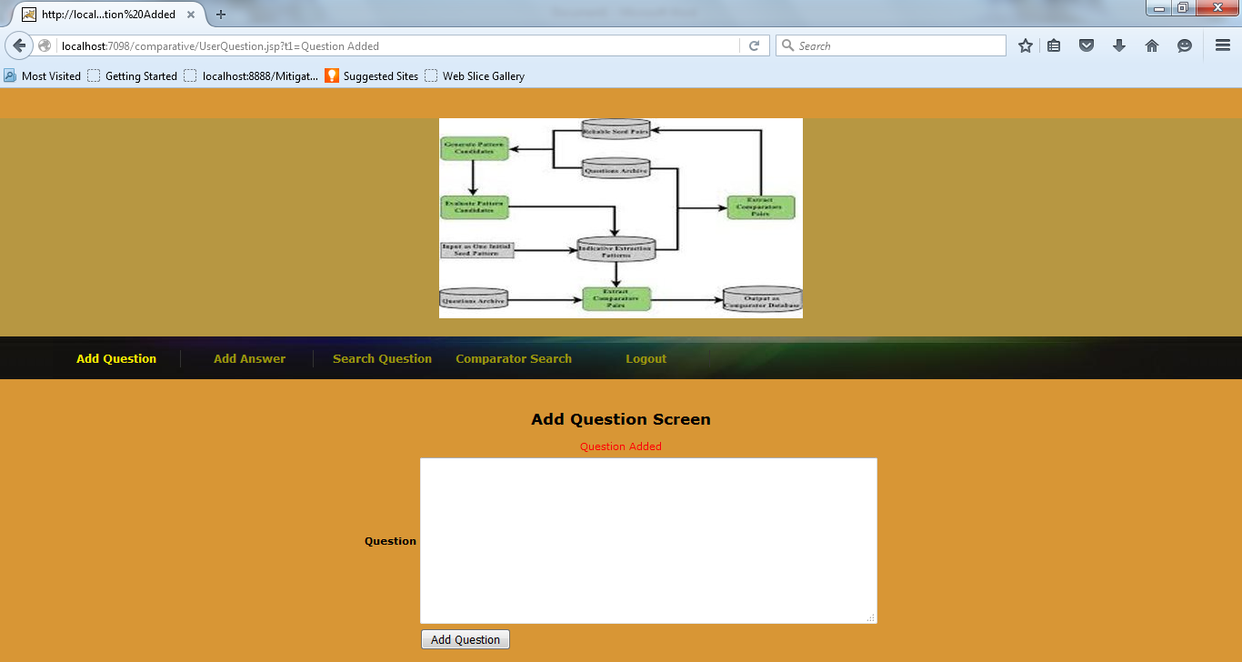

User to give answer

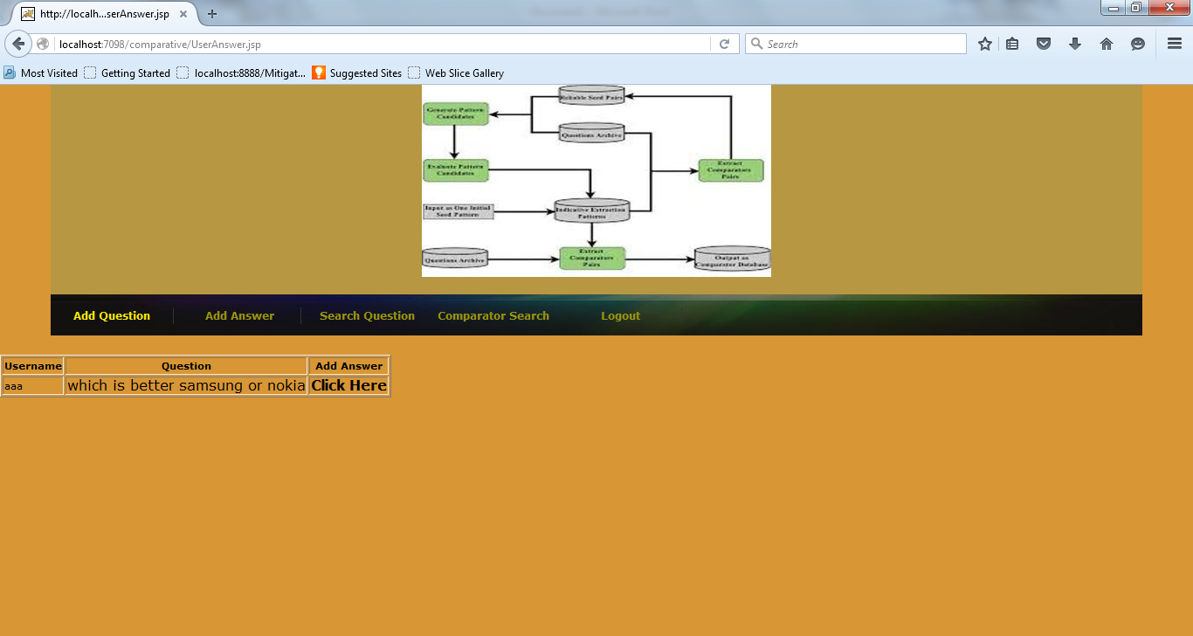

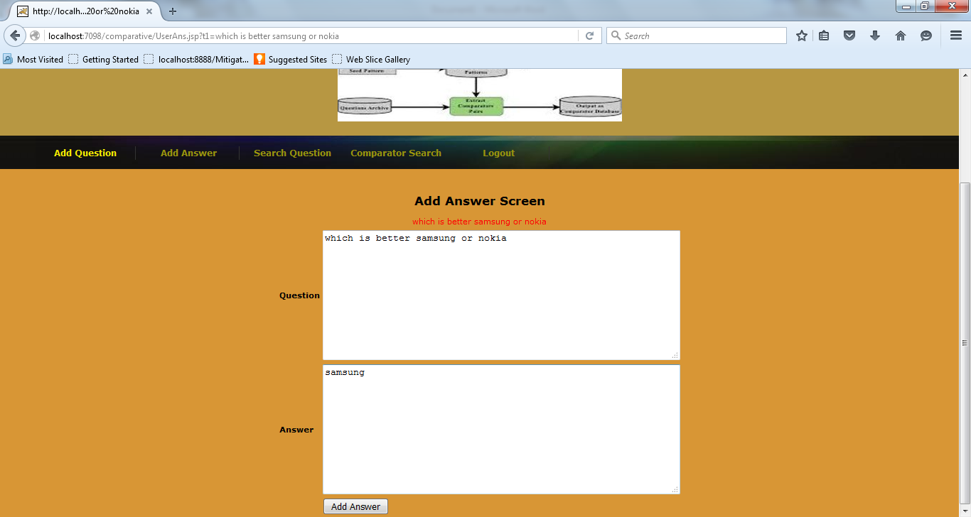

Throwing an error if the question entered by the user is not a comparable one.
Example

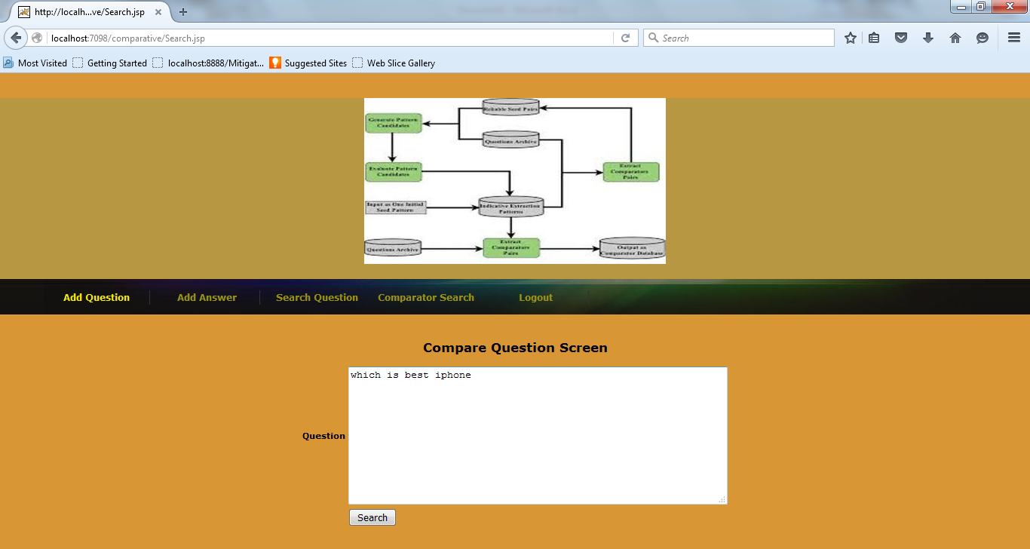

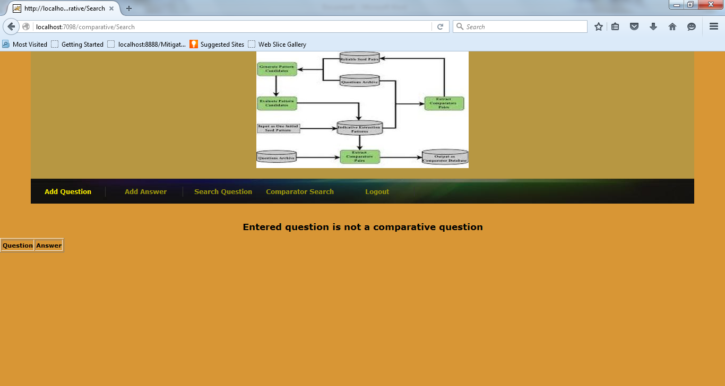

Now search for comparative question

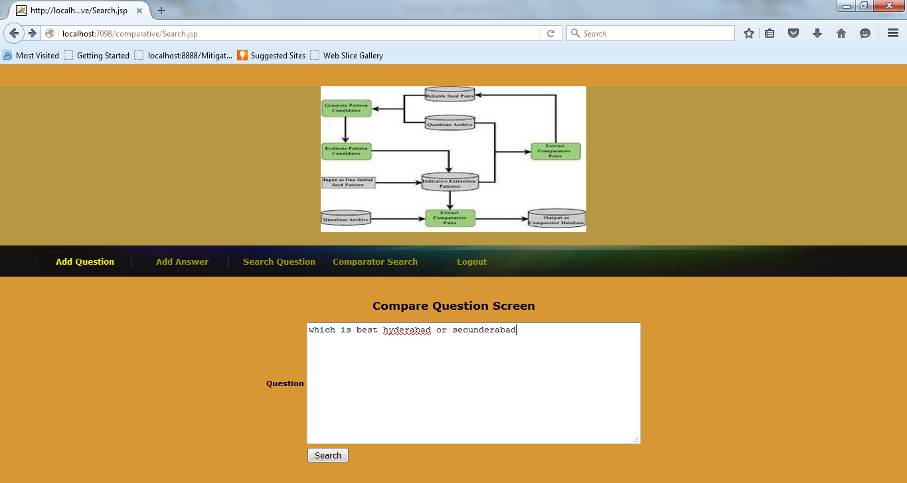

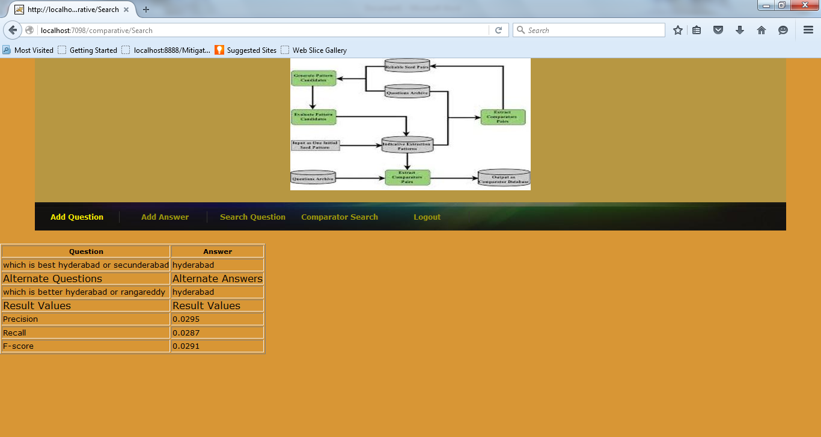

Comparator search example

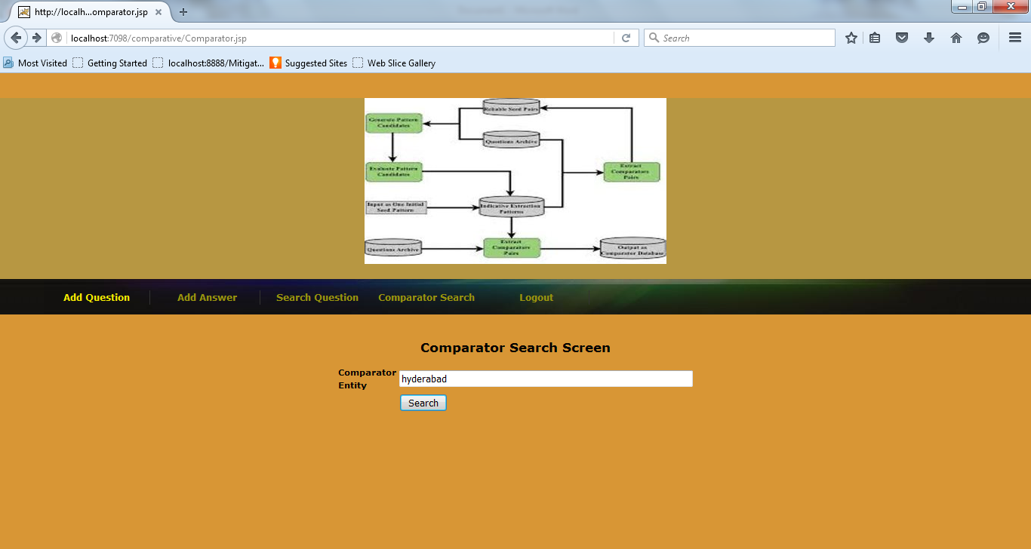

Comparator entity search result

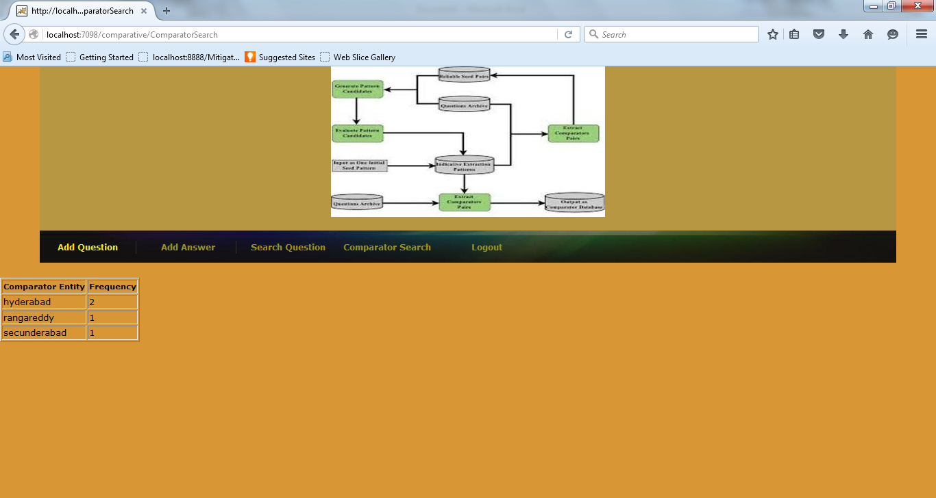

Comparator frequency chart

